University of Agriculture, Faisalabad

Submitted to:
Mam Misbah
Submitted by:
Name:
Qurat ul Ain
Registration no:
2023-ag-9777
Degree:
BS(BI)-6th-M2
Course Title:
Computational Biology
Course code:
Binfo - (502)

Protein Structure Prediction Using AlphaFold and Related Tools
Introduction:
Protein structure prediction is a key area of computational biology because the 3D structure of a protein determines its function. Experimental methods such as X-ray crystallography and cryo-electron microscopy are accurate but time-consuming and not suitable for all proteins, which has led to the development of advanced computational approaches. A major breakthrough in this field is AlphaFold, a deep learning-based system that can predict highly accurate protein structures directly from amino acid sequences, significantly advancing structural bioinformatics (Jumper et al., 2021).
The AlphaFold Protein Structure Database has further expanded access to predicted structures for entire proteomes. Recent studies and reviews show that AI-based tools, including AlphaFold and related methods, are widely used for functional annotation, protein–protein interaction analysis, and drug discovery, while also helping to understand protein flexibility and intrinsically disordered regions (Artificial Intelligence Review, 2025). AlphaFold and public release of hundreds of protein structures changed the field of structural biology and protein bioinformatics. Structural biology is now available for nearly every known protein sequence (Kurgan et al., 2025).
Objectives:
- To predict the three-dimensional structure of the target protein using AlphaFold-based modeling approaches.
- To evaluate the structural reliability of the predicted protein using pLDDT confidence scores.
- To identify and characterize flexible/disordered regions within the protein.
- To infer potential functional roles of the protein based on its structural features.
- To investigate possible involvement of the protein in molecular interactions, including protein-protein and ligand interactions.
- To provide a structural framework for future computational studies such as molecular docking, functional annotation, mutation analysis, regulatory and signal pathways.

Methodology:
Step 1: Selecting a Protein:
Protein name: Microtubule-associated protein tau
Gene name: MAPT
Sequence Length: 758 AA
Step 2: Retrieving the Protein Sequence:
I retrieved the structure from UniProt database and then downloaded the amino acid sequence in FASTA format.
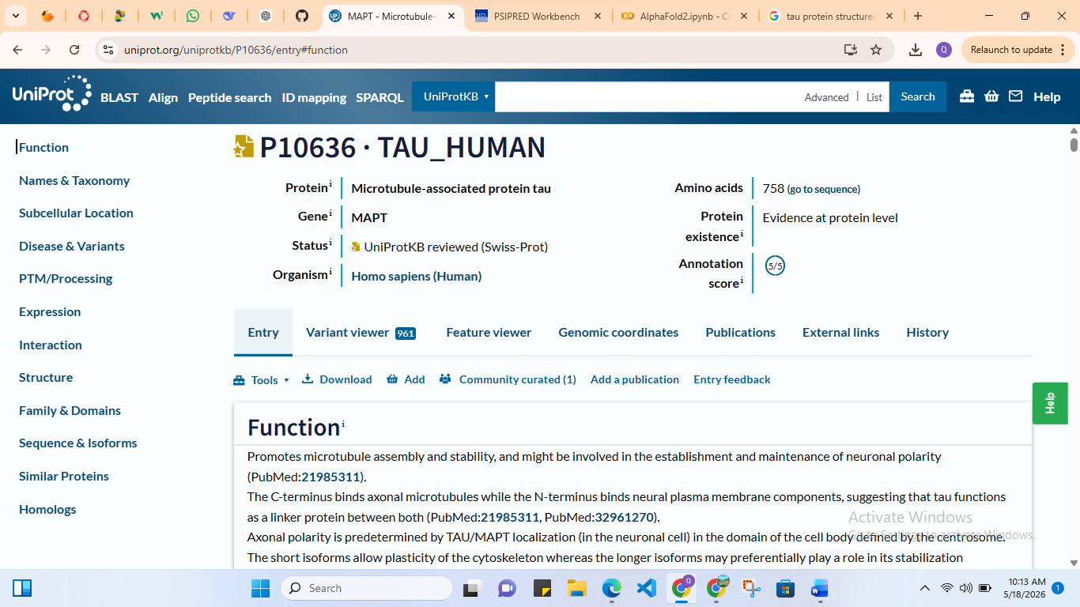


Step 3: Predicting Secondary Structure:
I uploaded the FASTA sequence to PSIPRED. Then, I recorded the percentages of alpha helices, beta sheets, and random coils. I also downloaded image in “svg” format.
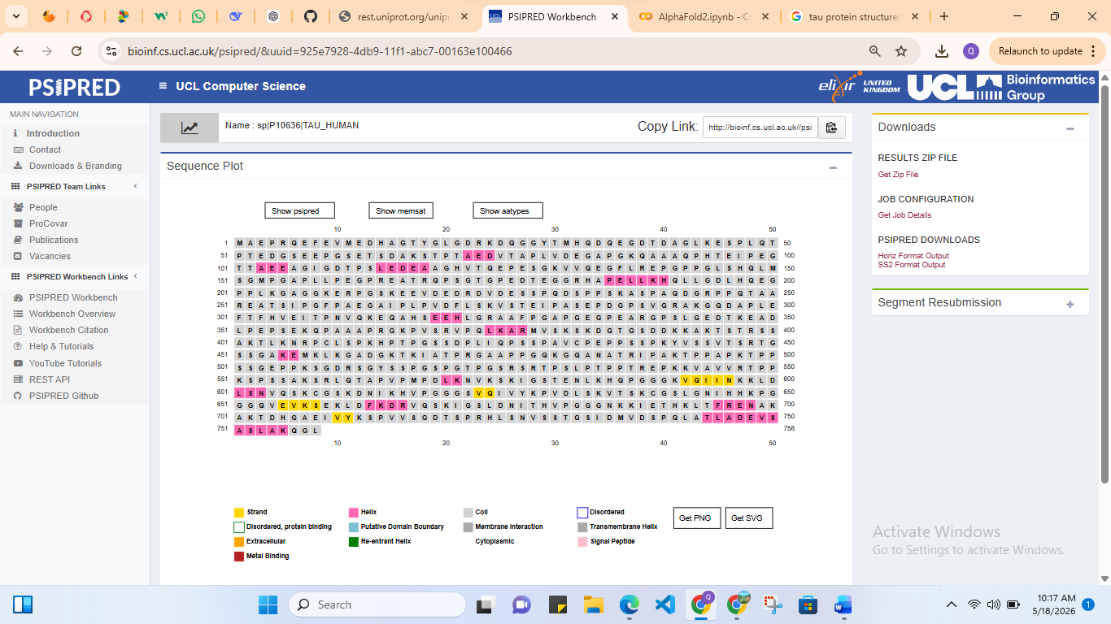
Interpretation:
Overall Secondary Structure Composition Structure:
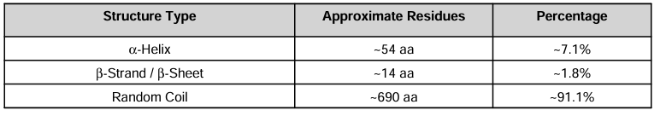
• Secondary structure prediction revealed that the protein is predominantly composed of random coil regions (91.1%), with low proportions of α-helices (7.1%) and β-strands (1.8%).
• Short α-helical segments were distributed throughout the sequence, suggesting roles in local structural stabilization and molecular interactions.
• Very low β-sheet content indicates the absence of a stable β-sheet-rich globular core.
• The dominance of coil regions suggests that the protein is likely intrinsically disordered or partially disordered.
• Intrinsically disordered proteins are commonly associated with:
(Protein–protein interactions, Cellular signaling, Molecular recognition, Regulatory functions, Structural flexibility)
• The protein likely exhibits dynamic conformational behavior and may undergo induced folding upon target binding.
• Overall, the predicted structure indicates a highly flexible, non-rigid biomolecule that may function primarily through adaptive molecular interactions rather than classical enzymatic activity.
Step 4: Predict 3D Structure
I opened AlphaFold notebook and pasted the FASTA sequence, then run the prediction to generate the 3D protein structure. As, the taken protein is highly disorded, so I was unable to make its 3D structure. Therefore, I chose its small, ordered sequence (244-368).
Step 5: Downloading Predicted Structure
I downloaded the generated PDB structure file and other graphs for further analysis. 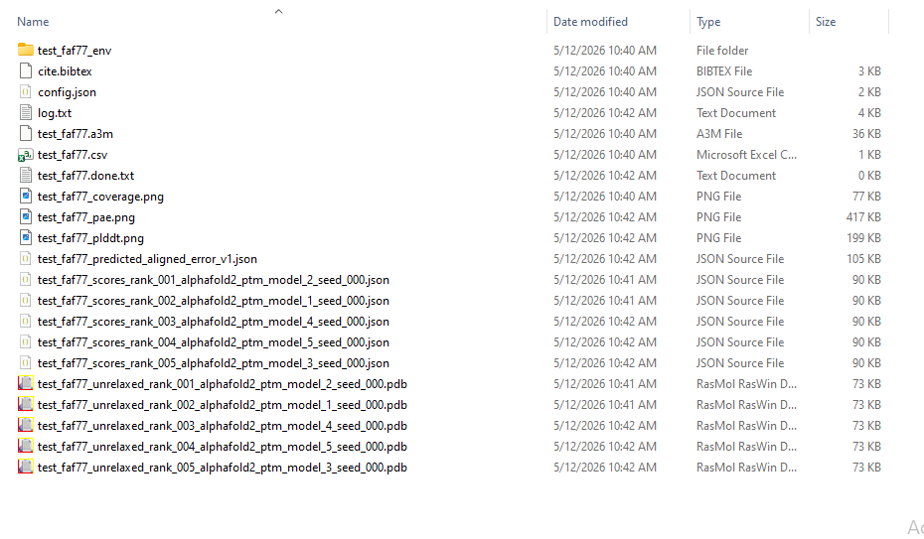
In it, the “.png” format are the graphs and “.pdb” are predicted structures in 5 different models.
Step 6: Visualizing the Structure:
I opened the PDB file in PyMOL.
- Changed the color and display:
>>>show cartoon
>>>color white
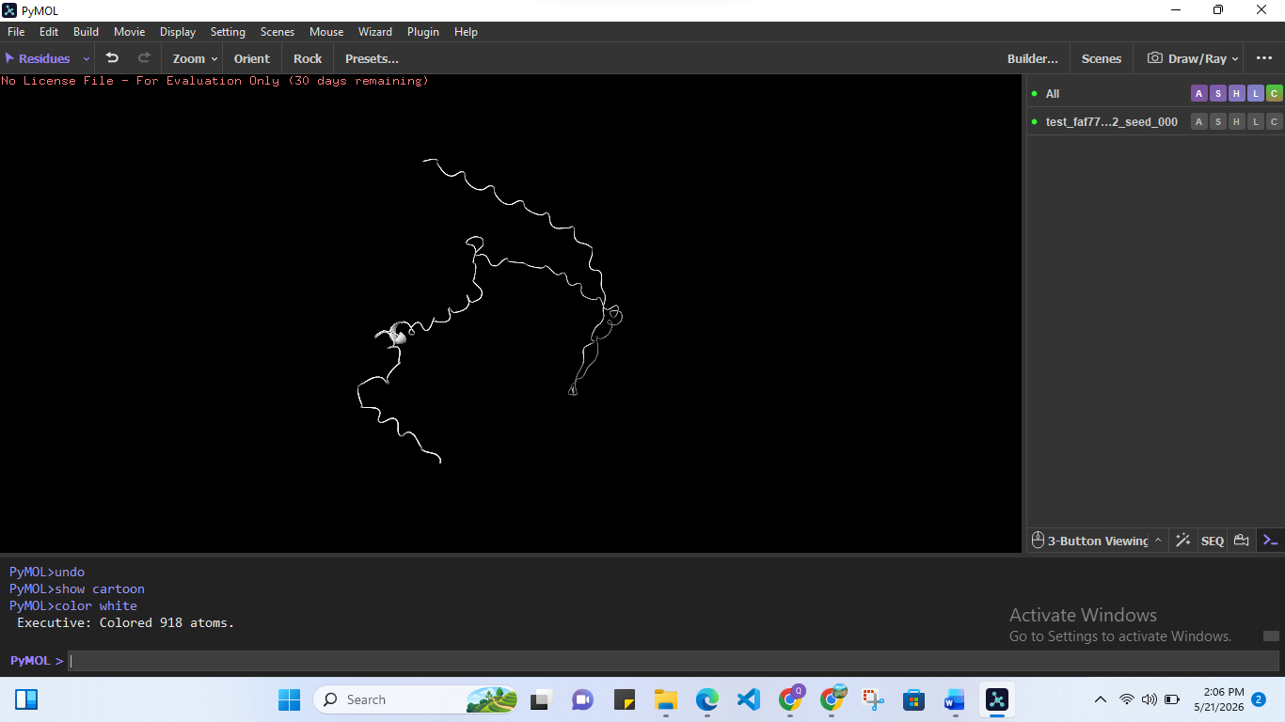
- Selecting helix & changing its color to red [Total 4 atoms]:
>>>color red, ss h
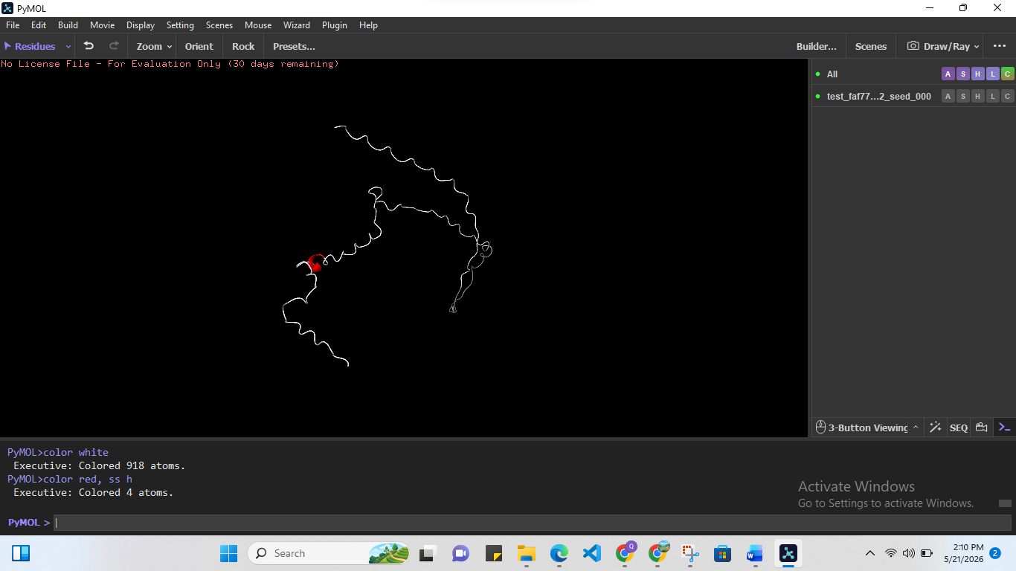

- Selecting loops, changing its color to yellow [Total 121 atoms]:
>>>color yellow, ss l
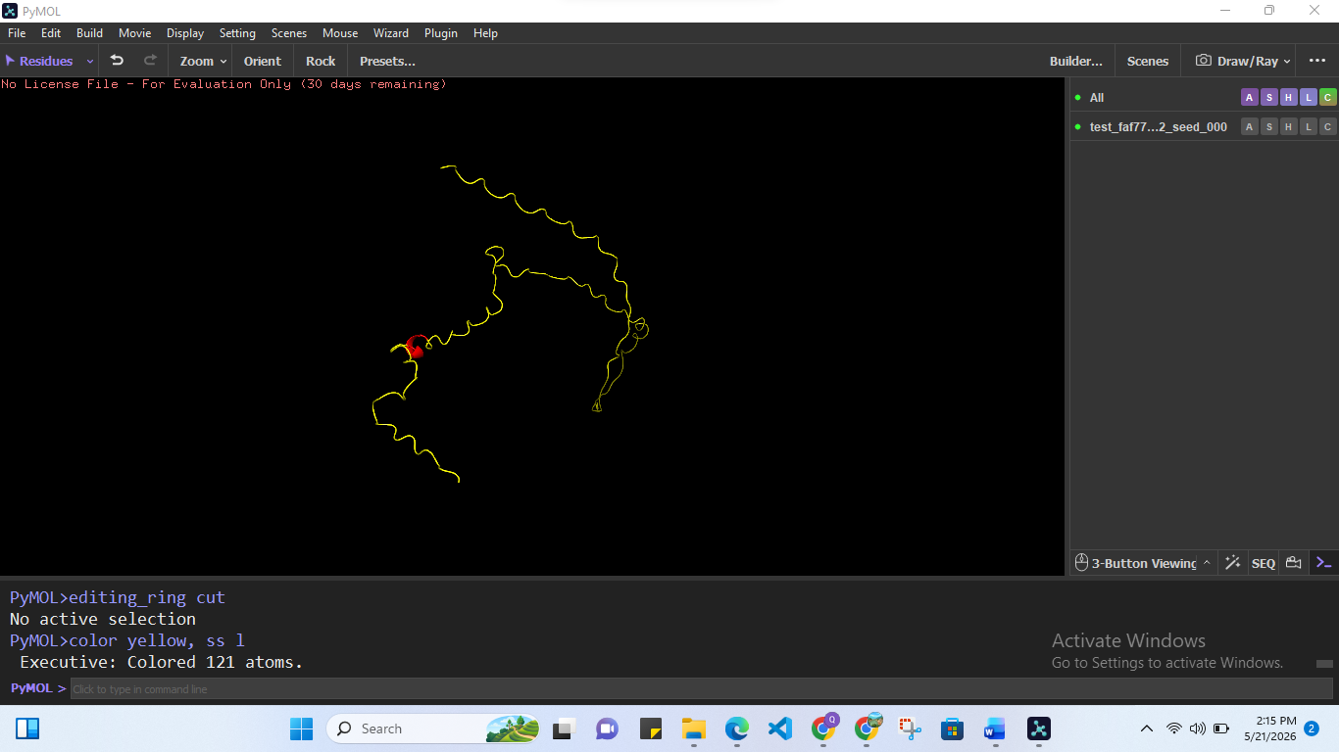

- Showing binding surface (for visualizing cavities, interaction regions, exposed residues):
>>>show surface
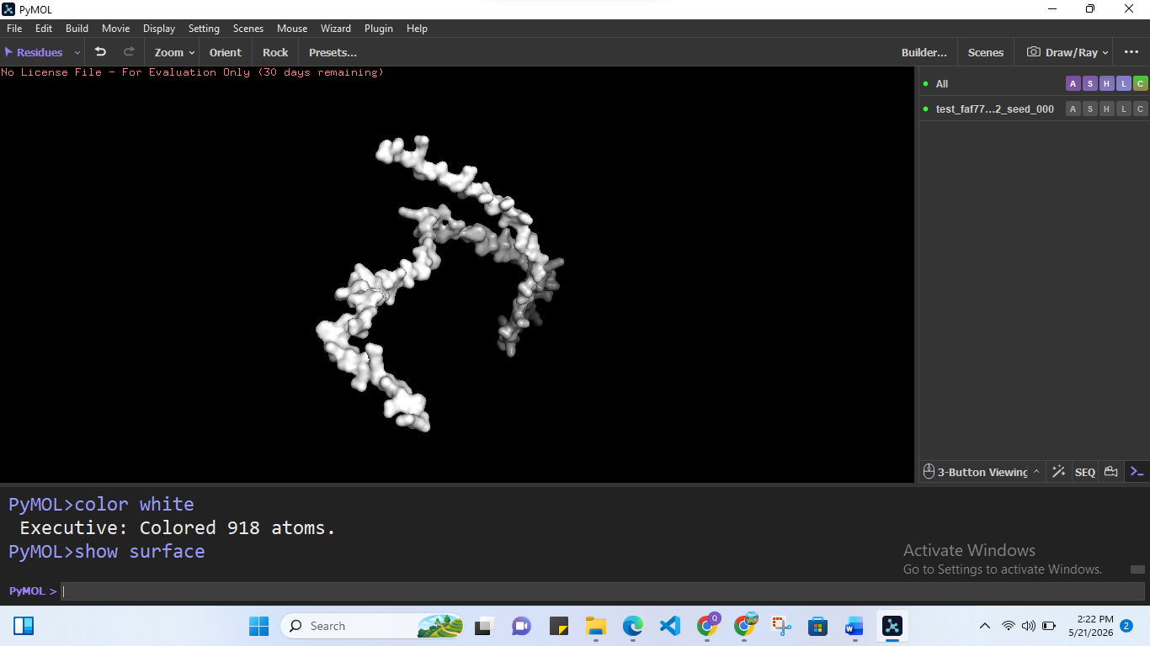

- Highlighting active/binding residues (for mutation sites, catalytic & Binding residues) [Total 18 atoms]:
>>>select site, resi 45+67+89
>>>show sticks, site
>>>color red, site

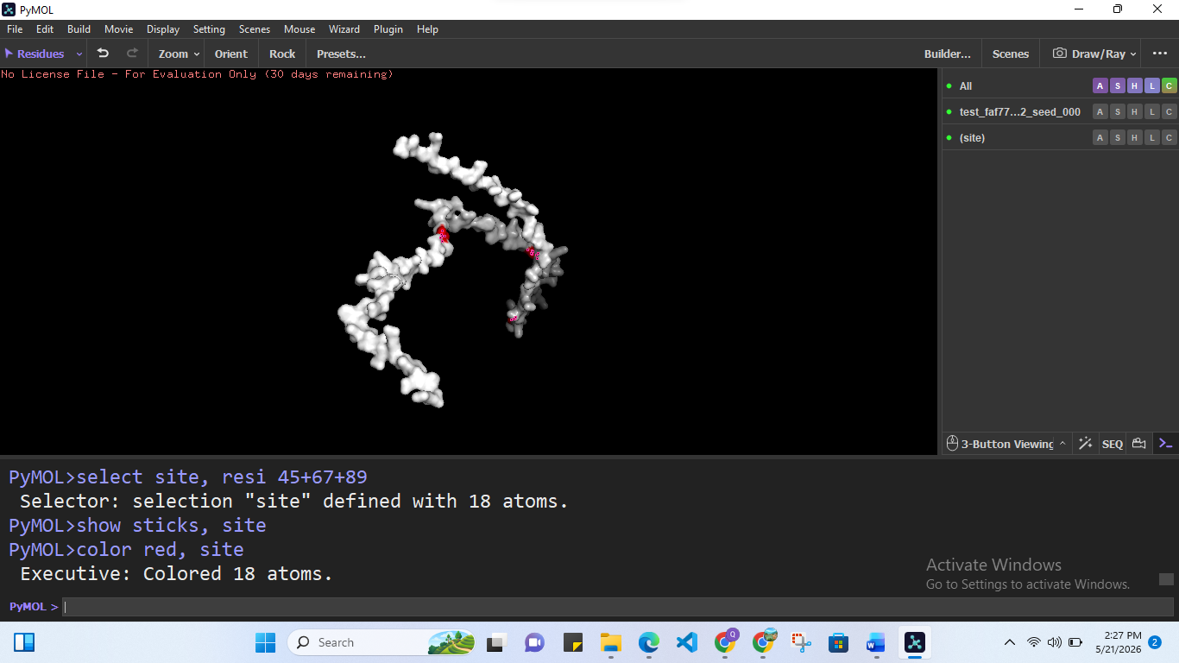
- Setting transparency:
>>>set transparency, 0.4
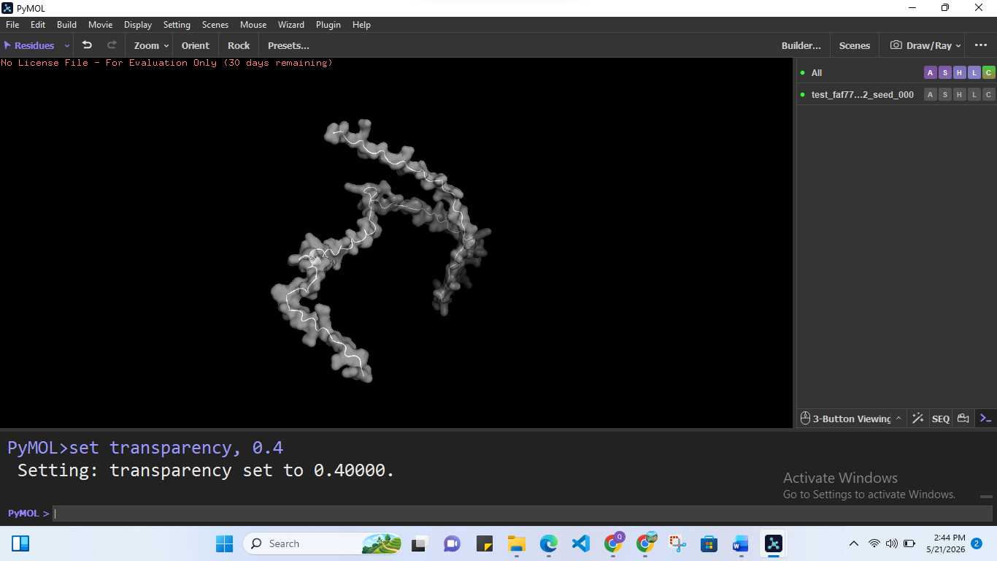

- Showing sticks:
>>>show sticks
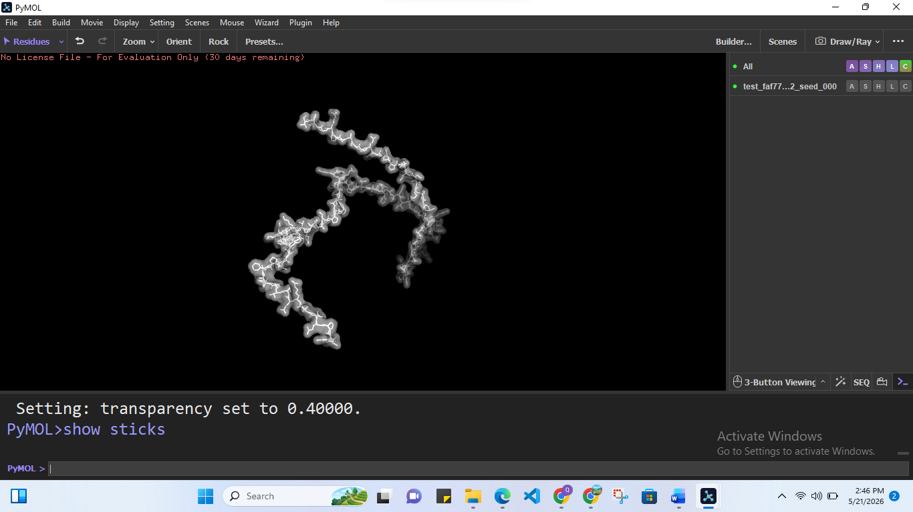

- Coloring by confidence (for visualizing reliable/ flexible regions, identify disorders) [high confidence; blue, low confidence; red]:
>>> spectrum b, blue_white_red
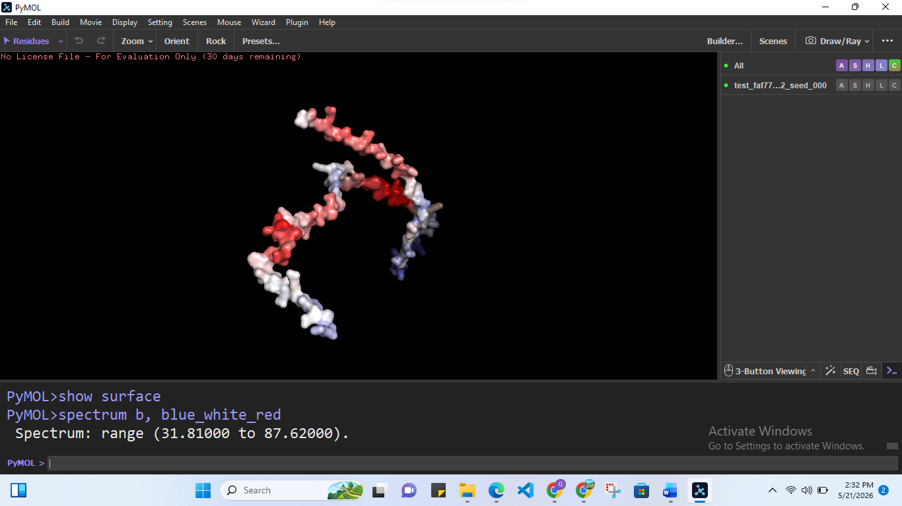

- Hydrogen bonds/Interaction:
>>>hbonds, donor, receptor
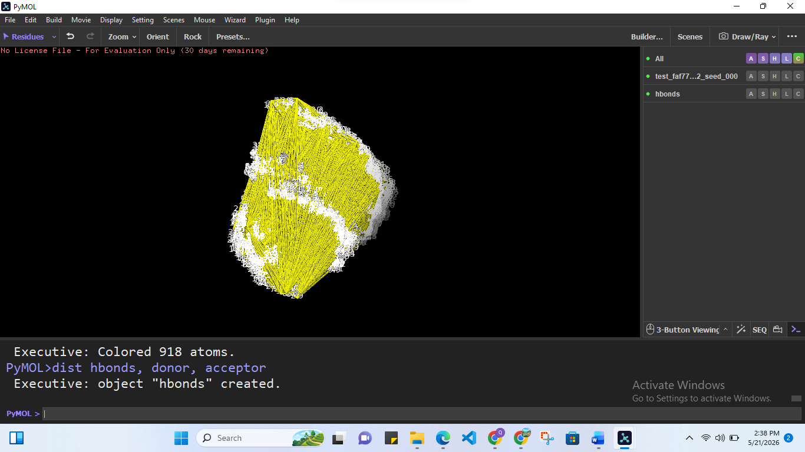

Step7: Analyzing the Structure:
After downloading the structure in pdb format and all graphs in png format, I analyzed them properly.
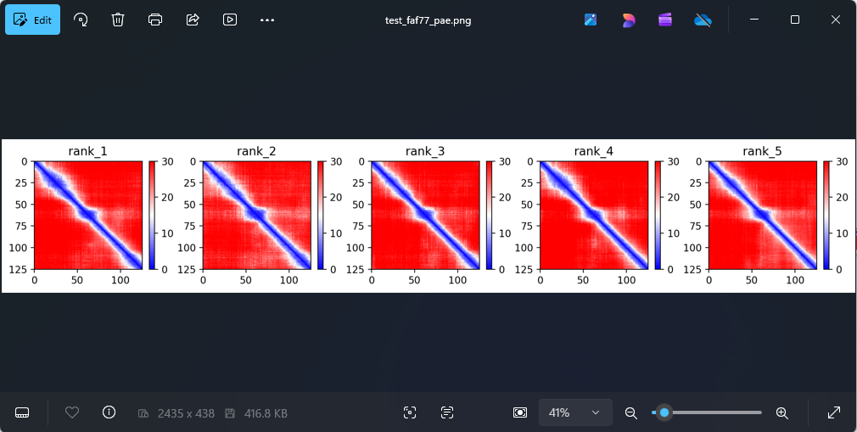
Predicted Aligned Error (PAE) Analysis:
- PAE maps of the five ranked models showed strong blue diagonal regions, indicating high confidence in local residue positioning.
- Limited off-diagonal interactions suggest weak or flexible long-range residue interactions.
- Similar structural patterns across all five models demonstrate consistent and reliable structural predictions.
- Red background regions indicate higher uncertainty in distant residue relationships and domain orientations.
- The results suggest that the protein contains:
  - Stable locally folded regions
  - Flexible or dynamic domains
  - Potential conformational adaptability
Overall, the protein is predicted to possess a combination of locally stable structures and flexible long-range organization.
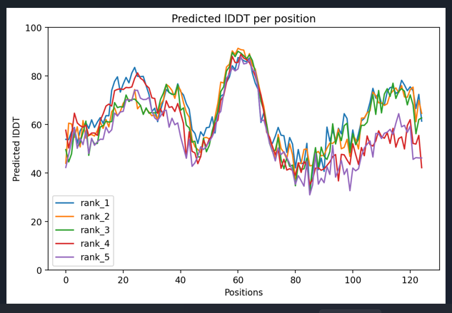
Predicted IDDT (pLDDT) Confidence Analysis:
- The pLDDT confidence plot was used to assess prediction reliability across amino acid positions.
- Residues 55–70 showed the highest confidence scores (~85–90), indicating well-defined and stable structural regions.
- Residues 15–40 and 105–120 displayed moderate-to-good confidence, suggesting partially stable conformations.
- Lower confidence scores were observed in residues 75–100, indicating possible flexible or intrinsically disordered regions.
- High-confidence regions are likely associated with stable secondary structures such as α-helices and β-sheets, whereas low-confidence regions may correspond to loops, flexible linkers, or disordered segments.
Overall, the protein appears to contain both stable structural elements and flexible regions, supporting dynamic functional behavior.
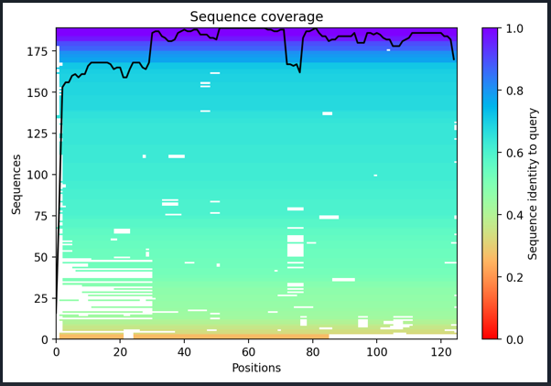
Sequence Coverage and Evolutionary Analysis:
- The sequence coverage analysis from the multiple sequence alignment (MSA) showed high coverage across most residue positions, indicating strong homologous support.
- Conserved regions likely correspond to structurally and functionally important domains preserved during evolution.
- Reduced coverage around residues 70-80 suggests the presence of flexible or variable regions.
- Highly conserved regions are typically associated with stable structural elements and essential biological functions.
Overall, the analysis indicates that key structural regions of the protein are evolutionarily conserved, while certain segments may exhibit structural flexibility or variability.

Overall Structural Statistics:
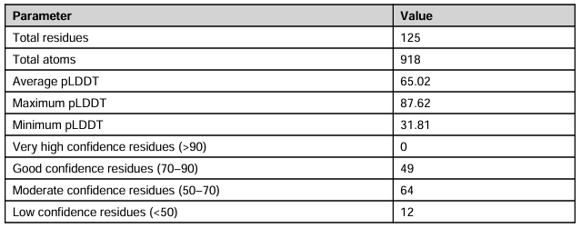
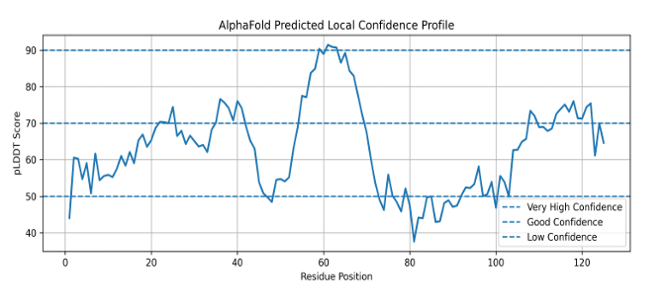
Amino Acid Composition:
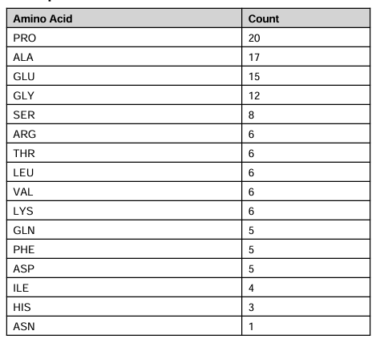

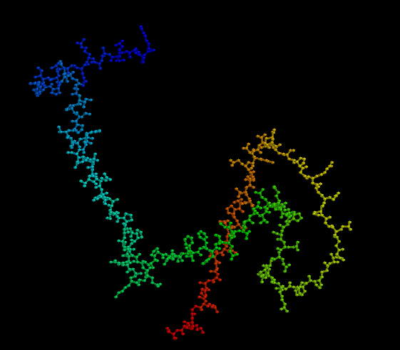
Results & Conclusion:
The AlphaFold predictions consistently indicate that the protein is partially ordered, containing both stable folded domains and flexible/disordered regions. Across models, the average pLDDT scores (~55.9–65.0) suggest a moderately reliable structural prediction, with well-defined core regions alongside flexible segments that contribute to structural variability.
Key structural features include:
- Presence of stable, well-folded domains with good confidence
- Coexistence of intrinsically disordered and flexible regions
- Overall moderate structural reliability with biologically meaningful flexibility
- Consistent indication of dynamic structural behavior across models
Functionally, this architecture suggests the protein is biologically adaptable, with flexibility supporting:
- Structural stability of core domains
- Molecular recognition and binding specificity
- Protein–protein interactions
- Regulatory and signaling functions
- Conformational adaptability during biological processes
The predicted structure provides a reliable framework for further computational and experimental studies, including:
- Molecular docking and interaction analysis
- Functional annotation
- Mutation impact studies
- Protein-protein interaction mapping
- Drug-target exploration
Overall, the protein is best characterized as a dynamically flexible biomolecule with stable structural cores, likely playing roles in interaction-driven and regulatory biological pathways.
Discussion:
The AlphaFold predictions across all models consistently reveal a structurally heterogeneous protein composed of both ordered (stable) and disordered (flexible) regions. Across the models, the average pLDDT scores range from ~55.9 to 65.0, indicating moderate overall structural confidence with reliable core regions.
Key structural observations include:
- Presence of stable structural cores or domains with relatively high confidence
- Multiple flexible or intrinsically disordered regions distributed throughout the sequence
- Overall moderate-to-high prediction reliability, with consistency across models
- Low-confidence regions are consistently observed and are not indicative of prediction errors
Biologically, this architecture suggests a protein that likely functions through dynamic and interaction-driven mechanisms, including:
- Cellular signaling and regulatory pathways
- Molecular recognition and adaptive binding
- Interaction with ligands and partner proteins
- Conformational flexibility and structural plasticity
The consistent presence of low-confidence regions across models highlights their likely role as intrinsically disordered segments, which are often functionally important rather than structurally unresolved. These regions may adopt defined conformations upon binding, contributing to induced-fit mechanisms and functional adaptability.
Overall, the protein is best described as a partially ordered, dynamically flexible biomolecule with stable structural domains embedded within a framework of flexible regions, supporting its role in regulatory and interaction-based biological processes.

References:
[1] Jumper, J., Evans, R., Pritzel, A., et al. (2021).
Highly accurate protein structure prediction with AlphaFold. Nature, 596(7873), 583–589.
https://doi.org/10.1038/s41586-021-03819-2
[2] Artificial intelligence-based methods for protein structure prediction: a survey. (2025). Artificial Intelligence Review. Springer Nature. https://doi.org/10.1007/s10462-025-11325-4
[3] Kurgan, L., & Yang, J. (2025). AlphaFold in protein structure and function prediction. Computational and structural biotechnology journal, 27, 5521–5522. https://doi.org/10.1016/j.csbj.2025.11.064

